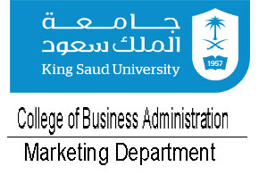**King Saud University**

**College of Business Administration**

**Department of Marketing**

**MKT 201: Principles of Marketing**

**Second Semester 2019-2020**

|  |  |  |  |
| --- | --- | --- | --- |
|  |  |  |  |

**REPORT(Guidelines)**

1. **INDUSTRY/MARKET**

* Industry/Market size and growth
* Describe any of the social, economic, technological, competitive, and regulatory trends/changes that may be pertinent/relevant to the performance of Industry, both currently and in the future.
* Legal/Regulatory issues (if any)

1. **COMPETITION:** Major players in the marketplace(Competitors)
2. **CUSTOMER**: Customer needs/perceptions, demographics and supporting trends
3. **COMPANY**

* Vision and/or mission statement of the firm
* Description (core competencies) and value proposition
* Analyze your market segmentation
* Analyze your target market (Who they are? What are they like? What are their needs?)

1. **Marketing mix** for applicable products and/or services
   * **Product/Service**
   * **Promotion – integrated marketing communications (IMC)**
   * **Place – distribution** Participants or partners that comprise the Supply chain (i.e., suppliers, distributors, retailers, customers)
   * **Pricing**
2. **EXPANDED SWOT ANALYSIS –** A SWOT analysis that also recommends ways to maximize the company’s strengths and opportunities and mitigate weaknesses and threats regarding the company and marketing the new or existing product or service.

A. Strengths

B. Weaknesses

C. Opportunities

D. Threats

E. Strategies to maximize strengths and opportunities

F. Strategies to mitigate weaknesses and threats